October 7, 2022

To: All Newton Canadian Baseball Association members

On behalf of the NCBA I would like to thank you for your participation in the 2022 season. As it concludes we are legally obligated to hold an Annual General Meeting. We are a member of the Societies Act and operate as a Non-Profit Organization. At each year-end we are required to report financial status to stakeholders, specifically the NCBA membership. We are required to have a board and report to the Provincial Government. We literally must satisfy Provincial Statute Law, to wit: Section 73 of the BC Societies Act. We cannot function without an AGM.
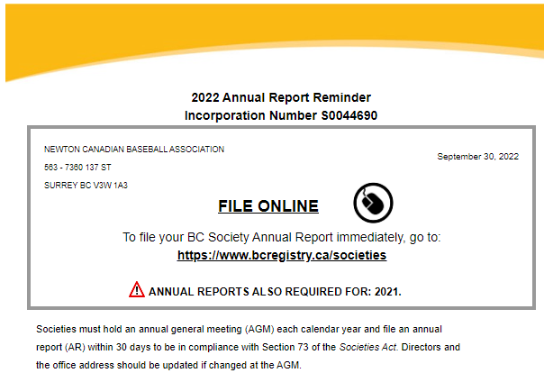
To be incorporated within the Societies Act the NCBA filed a Societies Act Document which we use as our Constitution and By-Laws. If we don’t have an AGM we dissolve and forfeit our funds to, “a registered charity or registered charities in British Columbia as defined in the Income Tax Act (Canada).” Voting members include parents whose children are registered along with coaches and managers.

A quorum is 20 voting members. We need to have 20 people attend the AGM. However, we really need all of you. Please make yourselves available for November 23rd or we lose our association and all its assets.
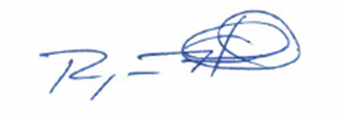
Sincerely,

______________
Ryan Hall
President
Newton Canadian Baseball Association

